Line interface with Scheduler

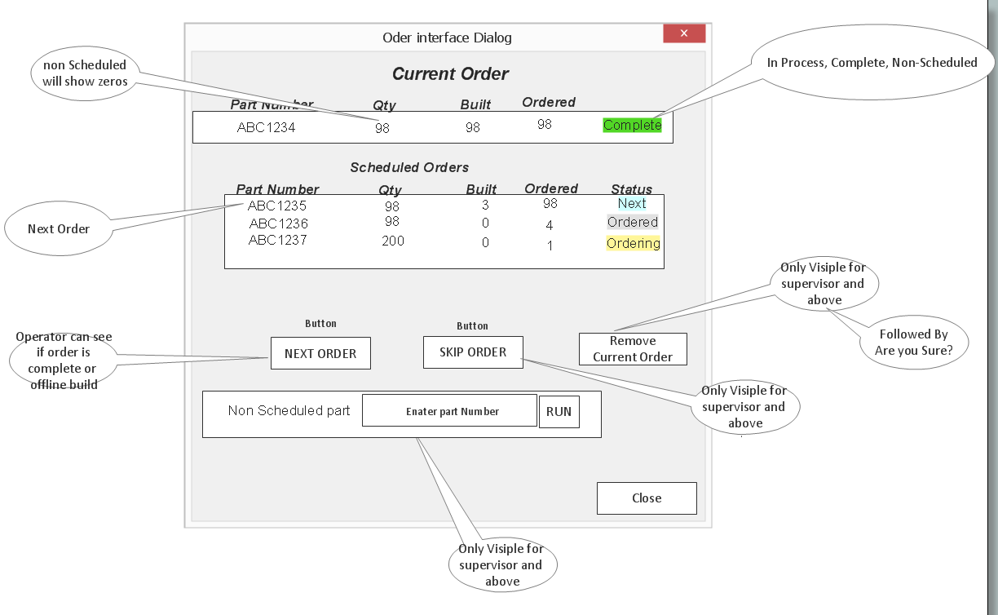
Open screen
Using WCF function GetScheduledOrders Returns Schedluled orders
get list of scheduled orders place current order up top and remaining below if there is not a current order they all go below
Next Order
Tester application will act on a command register requesting NEXT order. Call WCF Function GetNextOrder it returns the next order in line, it in turn is sent to PLC tag ProductionOrder. OrderId,PartNumber,Qty,buildt,Ordered
If the order interface dialog is up it would need to be refreshed it the next order was loaded
The plc wil be responsible for determining if the order can be loaded or requestes or not based on access level abd remainig part left in existing order
Skip Order
Supervisor presses this button and the WCF function is called SkipCurrentOrder.
Current order is resorted to the back of the scheduled queue and the next is presented as the current order. That order is sent to the plc ProductionOrder. OrderId,PartNumber,Qty,buildt,Ordered
Pressing skip order just repeats the process shifting the scheduled items around.
There is no bar code for skip and plc will not be processing it
Remove Order
From order interface dialog this button is only visable to supervisoe and up and acts on the current selected order if there is and order id > 0 and supervisor or greater is logged in the user can press it
And call the WCF function RemoveOrder By its ordered after the function is complete
Wipe the current order from the plc then refresh the scheduled orders list.
User will need to scan “NEXT” bar code or press next button on Order interface dialog screen.

Bar code scans
Plc will handle the bar code scans
“NEXT” is current order complete and is operator level or greater present
“PRODUCTION” move part information to current part, lookup data set production active count down and log part cycles or groups
“PZEBRA1” or any number preceded by a “P”– turn production active to off push ZEBRA1 to current part number , request all part info from sedatapro run your zebra

Plc interface with Scheduler
New udt called Udt_Order, OrderId Dint, partNumber String32, Qty dint, Buildt Dint, Ordered Dint, Remaining Dint
Creates a tag called CurrentOrder type UdtOrder
Change to orderId > 0 caused the orders part number to be pused to current part number and production status to active. In turn the plc will request the part option information from sedatapro
And completed cycles count the number of cycles in a given time span and report to sedatapro the counts and the order id.
Log , reset on any change in time span or orderId or production status if there are accumulated counts

Non-scheduled parts
On the order interface dialog, supervisor and up may enter part number of there choosing
Pressing run will send this value to the same memory as the bar code scan. PLC will act on it
Displacing the current part number and turning off production active. Entering a P as the first character will let the PLC know that you would like to load information for this part number.

Dialog Box Completion
Pressing Close button will close the screen
Pressing Run on the non-production part number entry will close the screen

